Project Development Phase
Performance Test

Date | 08 October 2026
Team ID | 9100RootAccess
Project Name | Auto Ticket Classification using ServiceNow Flow Designer
Maximum Marks

Model Performance Testing:
Project team shall fill the following information in model performance testing template.
S.No. | Parameter | Screenshot / Values
 | Data Rendered | New ticket form of Incident WorkFlow showing Number, Caller, Category, Subcategory, Short description, Description, State, Assigned group and Assigned to.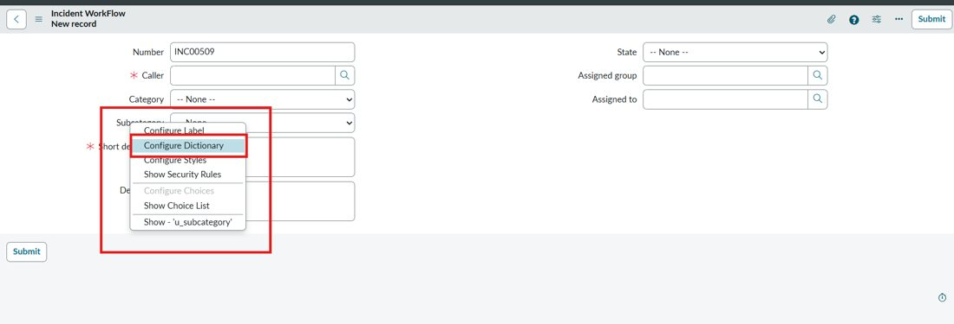  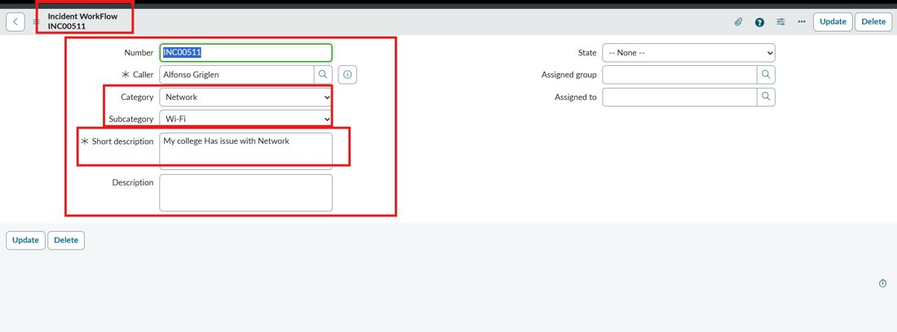
 | Data Preprocessing | Auto Number enabled on the table (Prefix INC, starting number 500, 5 digits). Choice values added for Category (Network, Hardware, Access, Performance) and Subcategory (Wi-Fi, Projector, Forgot Password, Slow Computer).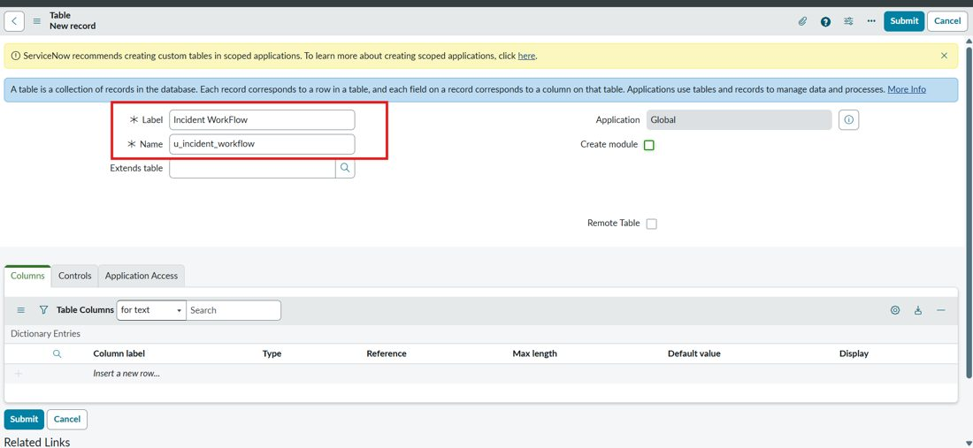  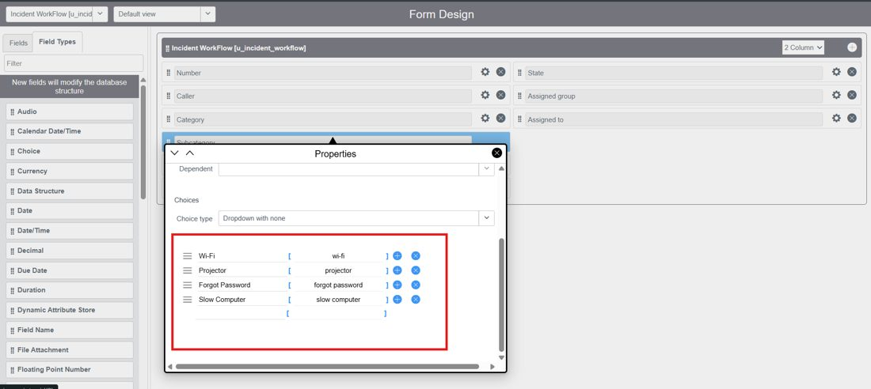
3. | Utilization of Filters | Trigger condition: Category is empty. Email log filtered with Subject contains “your” to verify the notifications sent.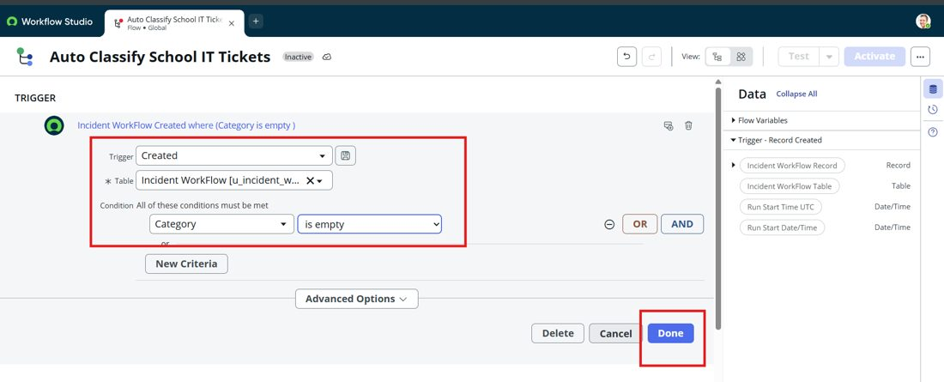  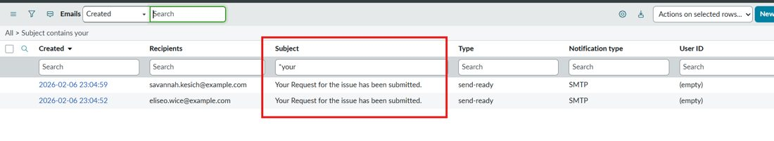
4. | Update Record field mappings (instead of calculation fields) | Wi-Fi: Category = Network, Subcategory = Wi-Fi  Projector: Category = Hardware, Subcategory = Projector  Password: Category = Access, Subcategory = Forgot Password  Slow computer: Category = Performance, Subcategory = Slow Computer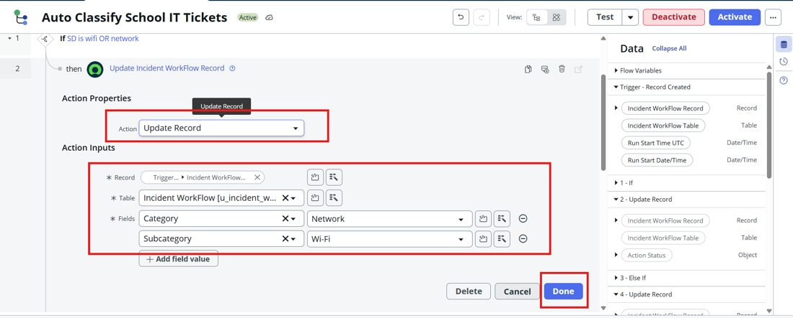  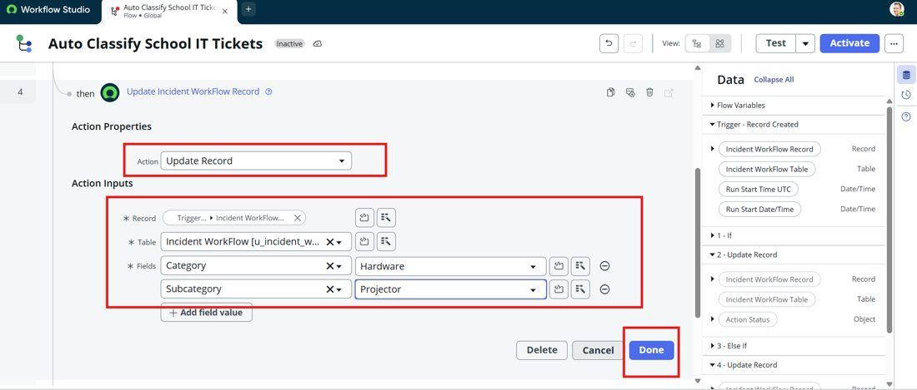
5. | Flow Design | No of Visualizations / Graphs – Not applicable. Flow “Auto Classify School IT Tickets” built in Flow Designer with 9 steps (4 conditions, 4 Update Record, 1 Send Email).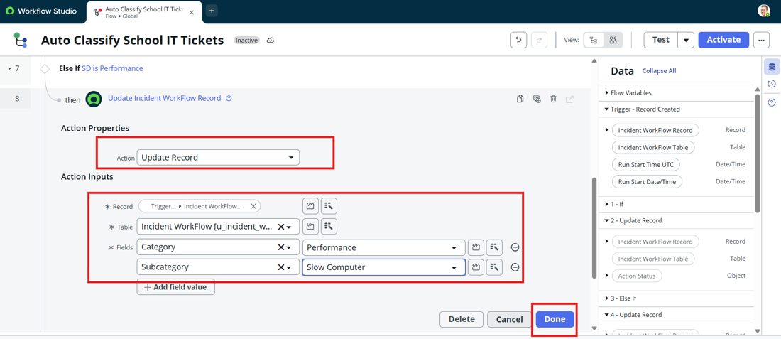
6 | Test Scenario Story | Scenario 1 – Short description “My college Has issue with Network” → Network / Wi-Fi  Scenario 2 – Short description “Projector not turning on” → Hardware / Projector  